Project -6

Bank loan Case

Project description:
The main aim of this project is to identify patterns that indicate if a customer will have difficulty paying their installments . This information can be used to make decisions such as denying the loan, reducing the amount of loan, or lending at a higher interest rate to risky applicants .

Approach:
This project is done by using “Excel” to analyse the data and provide valuable insight .This step involves preprocessing the data to make it suitable for analysis .

Tech-stark used:
In this project I used Excel because we can easily import data from various source and it is all-in-one tool for both database management and data analysis, allowing working efficiently.

Insights:
I learned how to work on a real-time project and it enhanced my knowledge and insight into the data.

DESCRIPTION ABOUT THE PROJECT:
A. Identify Missing Data and Deal with it Appropriately:
Task: Identify the missing data in the dataset and decide on an appropriate method to deal with it using Excel built-in functions and features.
To find total blank and null percentage we use countblank and count formula.
Table:
CONTENT | TOTAL BLANK COUNT | PROPORTION OF MISSING VALUES
SK_ID_CURR | 0 | 0
TARGET | 0 | 0
NAME_CONTRACT_TYPE | 0 | 0
CODE_GENDER | 0 | 0
FLAG_OWN_CAR | 0 | 0
FLAG_OWN_REALTY | 0 | 0
CNT_CHILDREN | 0 | 0
AMT_INCOME_TOTAL | 0 | 0
AMT_CREDIT | 0 | 0
AMT_ANNUITY | 1 | 0.00200004
AMT_GOODS_PRICE | 38 | 0.07600152
NAME_TYPE_SUITE | 192 | 0.38400768
NAME_INCOME_TYPE | 0 | 0
NAME_EDUCATION_TYPE | 0 | 0
NAME_FAMILY_STATUS | 0 | 0
NAME_HOUSING_TYPE | 0 | 0
REGION_POPULATION_RELATIVE | 0 | 0
DAYS_BIRTH | 0 | 0
DAYS_EMPLOYED | 0 | 0
DAYS_REGISTRATION | 0 | 0
DAYS_ID_PUBLISH | 0 | 0
OWN_CAR_AGE | 32950 | 65.90131803
FLAG_MOBIL | 0 | 0
FLAG_EMP_PHONE | 0 | 0
FLAG_WORK_PHONE | 0 | 0
FLAG_CONT_MOBILE | 0 | 0
FLAG_PHONE | 0 | 0
FLAG_EMAIL | 0 | 0
OCCUPATION_TYPE | 15654 | 31.30862617
CNT_FAM_MEMBERS | 1 | 0.00200004
REGION_RATING_CLIENT | 0 | 0
REGION_RATING_CLIENT_W_CITY | 0 | 0
WEEKDAY_APPR_PROCESS_START | 0 | 0
HOUR_APPR_PROCESS_START | 0 | 0
REG_REGION_NOT_LIVE_REGION | 0 | 0
REG_REGION_NOT_WORK_REGION | 0 | 0
LIVE_REGION_NOT_WORK_REGION | 0 | 0
REG_CITY_NOT_LIVE_CITY | 0 | 0
REG_CITY_NOT_WORK_CITY | 0 | 0
LIVE_CITY_NOT_WORK_CITY | 0 | 0
ORGANIZATION_TYPE | 0 | 0
EXT_SOURCE_1 | 28172 | 56.3451269
EXT_SOURCE_2 | 126 | 0.25200504
EXT_SOURCE_3 | 9944 | 19.88839777
APARTMENTS_AVG | 25385 | 50.77101542
BASEMENTAREA_AVG | 29199 | 58.39916798
YEARS_BEGINEXPLUATATION_AVG | 24394 | 48.78897578
YEARS_BUILD_AVG | 33239 | 66.47932959
COMMONAREA_AVG | 34960 | 69.92139843
ELEVATORS_AVG | 26651 | 53.30306606
ENTRANCES_AVG | 25195 | 50.39100782
FLOORSMAX_AVG | 24875 | 49.75099502
FLOORSMIN_AVG | 33894 | 67.78935579
LANDAREA_AVG | 29721 | 59.44318886
LIVINGAPARTMENTS_AVG | 34226 | 68.45336907
LIVINGAREA_AVG | 25137 | 50.2750055
NONLIVINGAPARTMENTS_AVG | 34714 | 69.42938859
NONLIVINGAREA_AVG | 27572 | 55.1451029
APARTMENTS_MODE | 25385 | 50.77101542
BASEMENTAREA_MODE | 29199 | 58.39916798
YEARS_BEGINEXPLUATATION_MODE | 24394 | 48.78897578
YEARS_BUILD_MODE | 33239 | 66.47932959
COMMONAREA_MODE | 34960 | 69.92139843
ELEVATORS_MODE | 26651 | 53.30306606
ENTRANCES_MODE | 25195 | 50.39100782
FLOORSMAX_MODE | 24875 | 49.75099502
FLOORSMIN_MODE | 33894 | 67.78935579
LANDAREA_MODE | 29721 | 59.44318886
LIVINGAPARTMENTS_MODE | 34226 | 68.45336907
LIVINGAREA_MODE | 25137 | 50.2750055
NONLIVINGAPARTMENTS_MODE | 34714 | 69.42938859
NONLIVINGAREA_MODE | 27572 | 55.1451029
APARTMENTS_MEDI | 25385 | 50.77101542
BASEMENTAREA_MEDI | 29199 | 58.39916798
YEARS_BEGINEXPLUATATION_MEDI | 24394 | 48.78897578
YEARS_BUILD_MEDI | 33239 | 66.47932959
COMMONAREA_MEDI | 34960 | 69.92139843
ELEVATORS_MEDI | 26651 | 53.30306606
ENTRANCES_MEDI | 25195 | 50.39100782
FLOORSMAX_MEDI | 24875 | 49.75099502
FLOORSMIN_MEDI | 33894 | 67.78935579
LANDAREA_MEDI | 29721 | 59.44318886
LIVINGAPARTMENTS_MEDI | 34226 | 68.45336907
LIVINGAREA_MEDI | 25137 | 50.2750055
NONLIVINGAPARTMENTS_MEDI | 34714 | 69.42938859
NONLIVINGAREA_MEDI | 27572 | 55.1451029
FONDKAPREMONT_MODE | 34191 | 68.38336767
HOUSETYPE_MODE | 25075 | 50.15100302
TOTALAREA_MODE | 24148 | 48.29696594
WALLSMATERIAL_MODE | 25459 | 50.91901838
EMERGENCYSTATE_MODE | 23698 | 47.39694794
OBS_30_CNT_SOCIAL_CIRCLE | 168 | 0.33600672
DEF_30_CNT_SOCIAL_CIRCLE | 168 | 0.33600672
OBS_60_CNT_SOCIAL_CIRCLE | 168 | 0.33600672
DEF_60_CNT_SOCIAL_CIRCLE | 168 | 0.33600672
DAYS_LAST_PHONE_CHANGE | 1 | 0.00200004
FLAG_DOCUMENT_2 | 0 | 0
FLAG_DOCUMENT_3 | 0 | 0
FLAG_DOCUMENT_4 | 0 | 0
FLAG_DOCUMENT_5 | 0 | 0
FLAG_DOCUMENT_6 | 0 | 0
FLAG_DOCUMENT_7 | 0 | 0
FLAG_DOCUMENT_8 | 0 | 0
FLAG_DOCUMENT_9 | 0 | 0
FLAG_DOCUMENT_10 | 0 | 0
FLAG_DOCUMENT_11 | 0 | 0
FLAG_DOCUMENT_12 | 0 | 0
FLAG_DOCUMENT_13 | 0 | 0
FLAG_DOCUMENT_14 | 0 | 0
FLAG_DOCUMENT_15 | 0 | 0
FLAG_DOCUMENT_16 | 0 | 0
FLAG_DOCUMENT_17 | 0 | 0
FLAG_DOCUMENT_18 | 0 | 0
FLAG_DOCUMENT_19 | 0 | 0
FLAG_DOCUMENT_20 | 0 | 0
FLAG_DOCUMENT_21 | 0 | 0
AMT_REQ_CREDIT_BUREAU_HOUR | 6734 | 13.46826937
AMT_REQ_CREDIT_BUREAU_DAY | 6734 | 13.46826937
AMT_REQ_CREDIT_BUREAU_WEEK | 6734 | 13.46826937
AMT_REQ_CREDIT_BUREAU_MON | 6734 | 13.46826937
AMT_REQ_CREDIT_BUREAU_QRT | 6734 | 13.46826937
AMT_REQ_CREDIT_BUREAU_YEAR | 6734 | 13.46826937

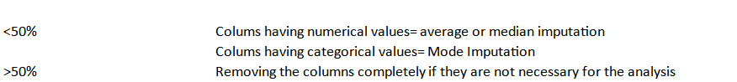

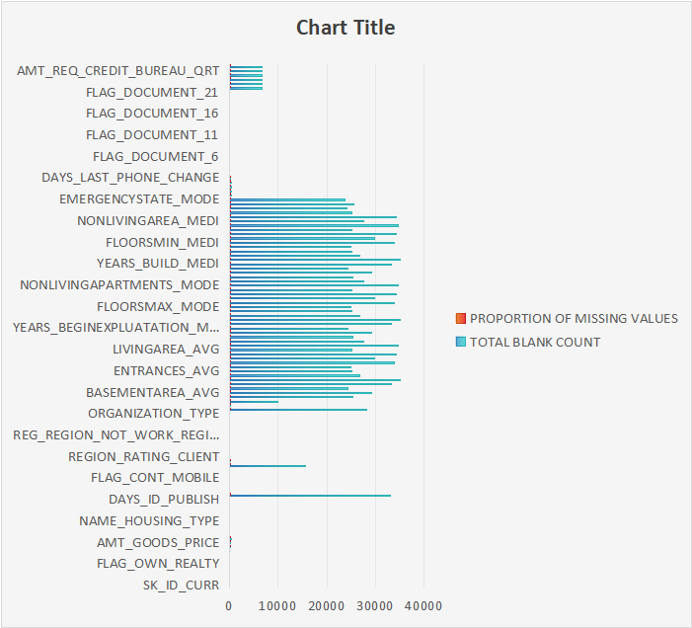

1.Data cleaning (application data)
drop the following column
Flag_WORK_PHONE , FLAG COUNT_MOBILE FLAG_PHONE, FLAG_DOCUMENT_2, FLAG_DOCUMENT_3, FLAG_DOCUMENT_4, FLAG_DOCUMENT_5, FLAG_DOCUMENT_6, FLAG_DOCUMENT_7, FLAG_DOCUMENT_8, FLAG_DOCUMENT_9, FLAG_DOCUMENT_10, FLAG_DOCUMENT_11,FLAG_DOCUMENT_12, FLAG_DOCUMENT_13, FLAG_DOCUMENT_14, FLAG_DOCUMENT_15, FLAG_DOCUMENT_16 , FLAG_DOCUMENT_17, FLAG_DOCUMENT_18, FLAG_DOCUMENT_19, FLAG_DOCUMENT_20, FLAG_DOCUMENT_21, EXT_SOURCE_2,EXT_SOURCE_3.
2. Data cleaning(previous application)
columns having a null value percentage of more than 30% are identified and deleted.
Drop the following column
WEEKDAY_APPR_PROCESS_START, HOUR_APPR_PROCESS_START, FLAG_LAST_APPL_PER_CONTRACT, NFLAG_LAST_APPL_IN_DAY

Content | total Total blank count blank | Total null %
SK_ID_PREV | 0 | 0
SK_ID_CURR | 0 | 0
NAME_CONTRACT_TYPE | 0 | 0
AMT_ANNUITY | 10592 | 21.18442369
AMT_APPLICATION | 0 | 0
AMT_CREDIT | 0 | 0
AMT_DOWN_PAYMENT | 25198 | 50.39700794
AMT_GOODS_PRICE | 10744 | 21.18442369
WEEKDAY_APPR_PROCESS_START | 0 | 0
HOUR_APPR_PROCESS_START | 0 | 0
FLAG_LAST_APPL_PER_CONTRACT | 0 | 50.39700794
NFLAG_LAST_APPL_IN_DAY | 0 | 21.48842977
RATE_DOWN_PAYMENT | 25198 | 0
RATE_INTEREST_PRIMARY | 49834 | 0
RATE_INTEREST_PRIVILEGED | 49834 | 0
NAME_CASH_LOAN_PURPOSE | 0 | 0
NAME_CONTRACT_STATUS | 0 | 50.39700794
DAYS_DECISION | 0 | 99.6699934
NAME_PAYMENT_TYPE | 0 | 99.6699934
CODE_REJECT_REASON | 0 | 0
NAME_TYPE_SUITE | 24243 | 0
NAME_CLIENT_TYPE | 0 | 0
NAME_GOODS_CATEGORY | 0 | 0
NAME_PORTFOLIO | 0 | 0
NAME_PRODUCT_TYPE | 0 | 48.48696974
CHANNEL_TYPE | 0 | 0
SELLERPLACE_AREA | 0 | 0
NAME_SELLER_INDUSTRY | 0 | 0
CNT_PAYMENT | 10592 | 0
NAME_YIELD_GROUP | 0 | 0
PRODUCT_COMBINATION | 8 | 0
DAYS_FIRST_DRAWING | 19160 | 0
DAYS_FIRST_DUE | 19160 | 21.18442369
DAYS_LAST_DUE_1ST_VERSION | 19160 | 0
DAYS_LAST_DUE | 19160 | 0.01600032
DAYS_TERMINATION | 19160 | 38.32076642
NFLAG_INSURED_ON_APPROVAL | 19160 | 38.32076642

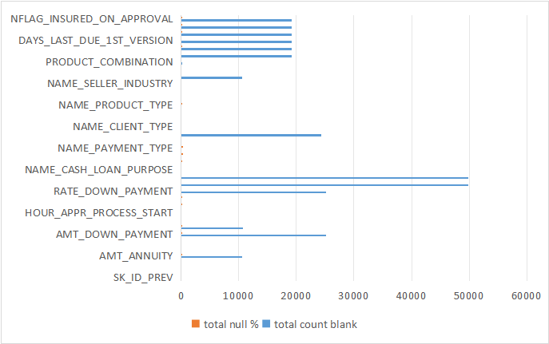

B. Identify Outliers in the Dataset
Task: Detect and identify outliers in the dataset using Excel statistical functions and features, focusing on numerical variables.
To find outlier we use quartile1,quartile2, quartile 3, IQR, Upper bound, Lower bound
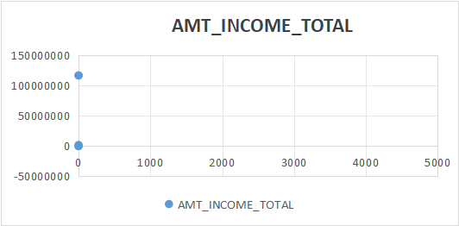
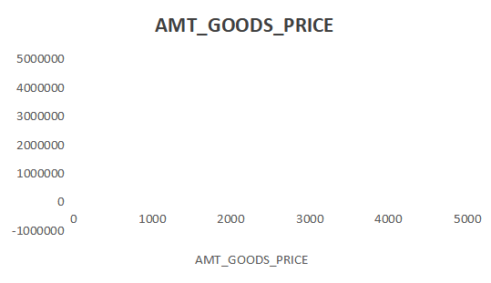

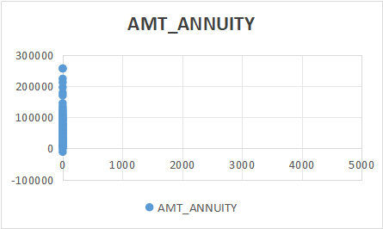
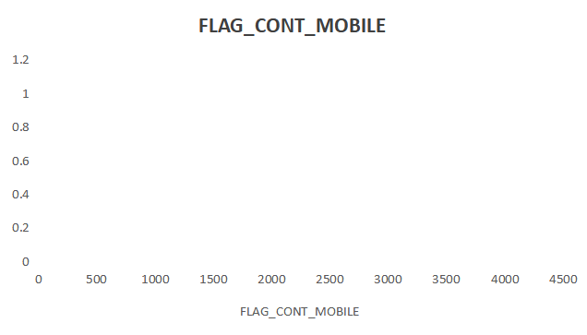

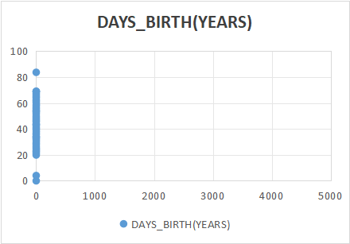

C. Analyze Data Imbalance:

Task: Determine if there is data imbalance in the loan application dataset and calculate the ratio of data imbalance using Excel functions .

Table:

CLASS 0(no payment difficulties) | CLASS 1(payment difficulties/data imbalance) | Ratio of data imbalance
45973 | 4026 | 11.41902633
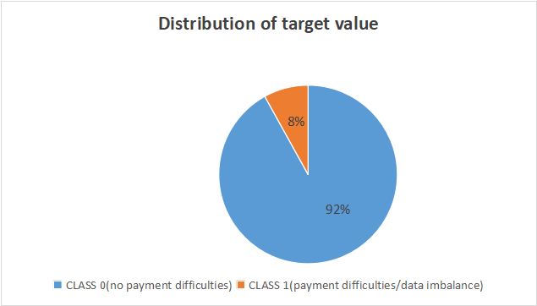

D. Perform Univariate, Segmented Univariate, and Bivariate Analysis:

Task: Perform univariate analysis to understand the distribution of individual variables, segmented univariate analysis to compare variable distributions for different scenarios, and bivariate analysis to explore relationships between variables and the target variable using Excel functions and features

Table:
INCOME BIN | Target 0 | Target 1
25k-50k | 741 | 63
50k-75k | 2980 | 246
75k-100k | 5826 | 536
100k-125k | 15975 | 1465
125k-150k | 7126 | 678
150k-175k | 5060 | 501
175k-200k | 4458 | 389
200k-225k | 6121 | 491
225k-250k | 4279 | 304
250k-275k | 1919 | 143
275k-300k | 681 | 45
300k-325k | 1076 | 59
325k-375k | 1045 | 58
375k-400k | 186 | 14
400k-425k | 263 | 26
425k-475k | 475 | 38
475K-500K | 44 | 3
5 Lacs and above | 423 | 31

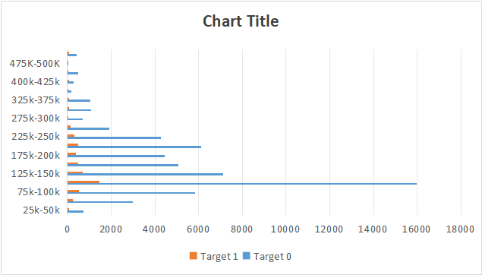

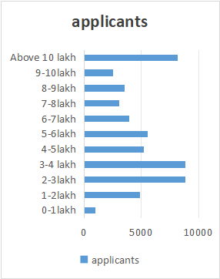  credit | applicants
0-1lakh | 989
1-2lakh | 4911
2-3lakh | 8849
3-4 lakh | 8849
4-5lakh | 5228
5-6lakh | 5554
6-7lakh | 3909
7-8lakh | 3062
8-9lakh | 3571
9-10lakh | 2548
Above 10 lakhs | 8146

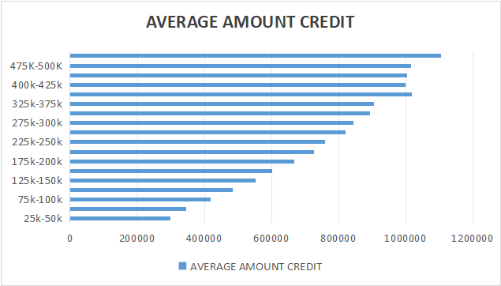  INCOME BIN | AVERAGE AMOUNT CREDIT
25k-50k | 297752.0765
50k-75k | 345240.3585
75k-100k | 417267.8771
100k-125k | 483568.8073
125k-150k | 553042.1642
150k-175k | 602034.4016
175k-200k | 667004.421
200k-225k | 727198.4449
225k-250k | 759541.3782
250k-275k | 820255.3451
275k-300k | 842725.6488
300k-325k | 892300.0718
325k-375k | 904707.0938
375k-400k | 1016814.375
400k-425k | 999208.199
425k-475k | 1004627.921
475K-500K | 1015150.404
5 Lacs and above | 1105365.122

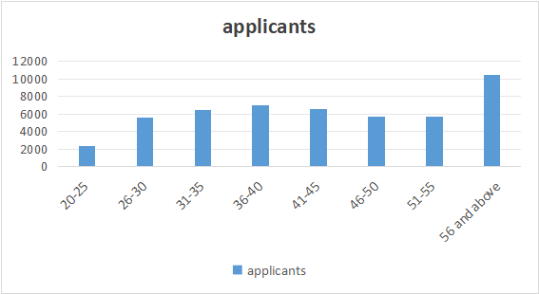
Age bin | applicants
20-25 | 2357
26-30 | 5574
31-35 | 6511
36-40 | 6996
41-45 | 6610
46-50 | 5718
51-55 | 5716
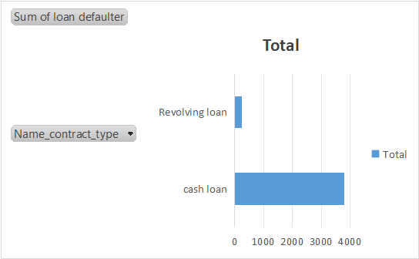  56 and above | 10523

Name_contract_type | Sum of loan defaulter
cash loan | 3792
Revolving loan | 234
Grand Total | 4026

CODE_GENDER | Sum of applicants
F | 4233189502
M | 2217056056
Grand Total | 6450245558
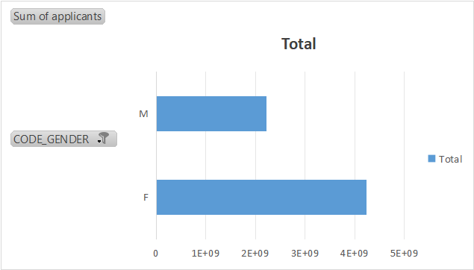

E. Identify Top Correlations for Different Scenarios:
Task: Segment the dataset based on different scenarios (e.g., clients with payment difficulties and all other cases) and identify the top correlations for each segmented data using Excel functions.
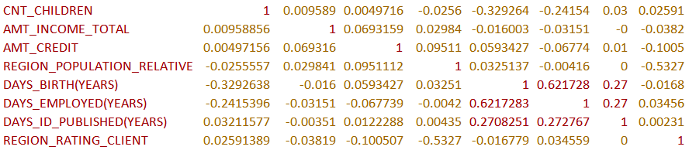

RESULT:
This project make us to work in “MS EXCEL”. It help me to describe statistics such as mean, median, mode and standard deviation of the data. It makes me to work lots in the insights towards the data and teach me how to approach the data.

The excel sheet link:
https://1drv.ms/x/c/bc338d8066a60ed8/EeuZUDAqld1AlNiZJTpPCusB1wB_pAYv0s8sg4AdA7A3Ng

